User Guide 30 Emailing and saving SPEAR documents
Purpose of this User Guide
The purpose of this User Guide is to provide guidance to SPEAR users on how to email or save multiple documents from SPEAR.
Who should read this?
Primary audience: Applicant Contacts, Responsible Authorities and referral authorities.
Introduction
SPEAR is an internet based application that enables Subdivision Act plans and planning applications to be electronically submitted to the Responsible Authority, referred to referral authorities and tracked online from the initial planning stage through to ‘Certification’ and issuing of ‘Statement of Compliance’ (SOC). The main components of SPEAR are only accessible to surveyors (Applicant Contact), Responsible Authorities, referral authorities, Land Use Victoria and public objectors.
Documents contained within each application are in PDF format. SPEAR makes it easy to email multiple documents to third parties or download and save them to a computer or document management system. This guide will outline these processes.
30.1 All SPEAR users: Email documents to a third party
Any PDF document in SPEAR can be emailed to a third party via the Email / Download Documents link. This option is available to all users in SPEAR at any stage through the application process.
Click on the link located under the blue SPEAR banner in the top right-hand section of the screen.
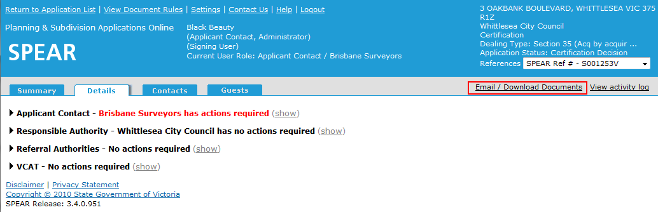

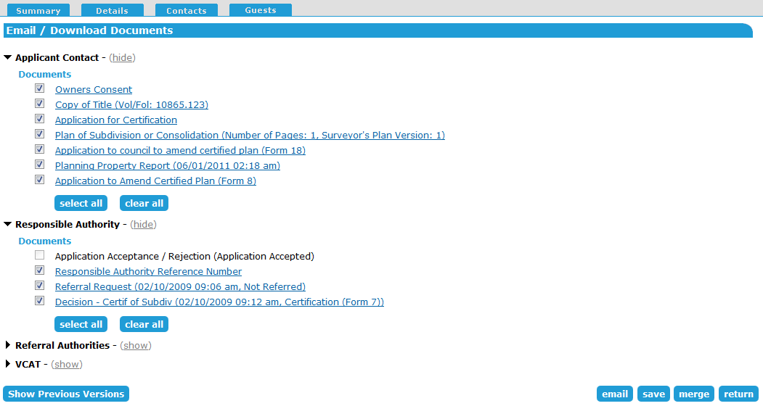
Select the documents you would like to email and click ‘email’. You can also view and select previous versions of the documents if required.
Enter the email address of the third party. You can elect to send a copy of the email to yourself and can also include optional text with the email. Check the box next to each document you would like to attach to the email and click ‘continue’.
An email will be sent automatically from SPEAR to the address you have indicated. The recipient will not require a SPEAR login to view these documents and will only be able to click on links in their notification email to view the PDF’s directly.
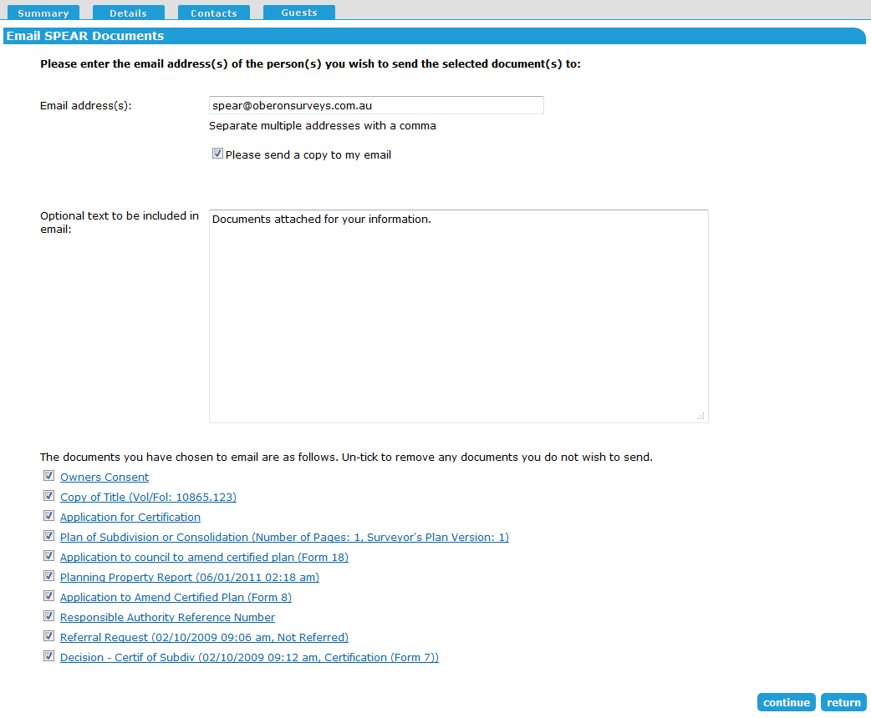
30.2 Applicant Contact: Email application documents to a lodging party?
The Applicant Contact has an additional option where they can specifically email the lodging party with key application documents and information about lodging a plan at Land Use Victoria.
This option is only available between the SPEAR application statuses of ‘Certification Decision’ and ‘Statement of Compliance’.
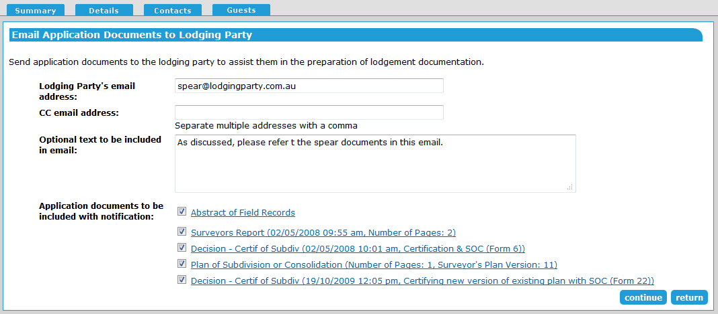
Choose ‘Email Application Documents to Lodging Party’ from the ‘Actions’ drop-down list under the Applicant Contact section and click ‘go’.

Type in the email address of the lodging party and an optional cc email address.
Tick the check box under the ‘Lodging Party Email address’ to automatically attach the SPEAR User Guide providing instructions for lodgment at Land Use Victoria.
You may include optional text within the email.
Check the boxes next to the documents you would like to attach to the email and click ‘continue’. This action requires password level authentication.
Applicant Contact’s should note that this does not replace the need to ‘Release for Lodgement’. The purpose of this email function is to notify the lodging party ahead of time that a plan application is nearing completion, so that they can start to prepare for lodgment.
30.3 How do I download and save multiple documents at once?
Using the ‘Email / Download Documents’ function, multiple documents can be downloaded at once for saving or printing.
On the Email / Download Documents screen, select the documents you would like to download and click ‘save’ or ‘merge’. You can also view and select previous versions of the documents if required.
Clicking ‘save’ will create a zip file containing the selected documents saved as separate PDF files. This option is useful if you need to save the individual documents to your computer or a document management system.
Clicking ‘merge’ will create one PDF file containing all the selected documents. This option is useful if you wish to print the documents or save them all in one file.
Where to get more information
Further information on this topic can be found by:
- Contacting the SPEAR Service Desk on 9194 0612 or email spear.info@delwp.vic.gov.au
- Selecting the Help link in the relevant area of the system.

